Click here, type the title of your paper, capitalize first letter only (not all words), Please type: do not copy & paste

First Author[1]* and Second Author2 (Please type)

*1First affiliation, City and Country (Please type)*

*2Second affiliation, City and Country (Please type))*

|  |  |  |
| --- | --- | --- |
| ARTICLE INFO |  | ABSTRACT |
| *Article history:*  Received XXX  Revised XXX  Accepted XXX  Online first  Published XXX |  | The abstract word count should not be more than 300 words. Please format your abstract using the ‘Abstract’ style in the styles gallery.  The **line numbers** on the left allow easier referencing and communication between the author and reviewers during double-blind peer review. Please **do not remove** the line numbers.  Please **do not edit or remove** any texts or objects highlighted in red colour.  Please **read the content of this guideline entirely**. Failure to adhere to this guideline shall lead to manuscript rejection at the desk evaluation stage. |
| *Keywords:*  keyword1  keyword2  keyword3  keyword4  keyword5  keyword6  *DOI:*  XXX |  |

1.0 INSERT your heading here (do not copy paste)

(10 pt) The article word count should not be more than 8000 words. The paragraphs continue from here and are only separated by headings, subheadings, images and formulae. The section headings are arranged by numbers, bold and 10 pt. Here are further instructions for authors.

1.1 Structure of MS Word Formatting

Files should be in MS Word format only and should be formatted for direct printing. Figures and tables should be embedded and not supplied separately. Please make sure that you use as much as possible normal fonts in your documents. Special fonts, such as fonts used in the Far East (Japanese, Chinese, Korean, etc.) may cause problems during processing. To avoid unnecessary errors, you are strongly advised to use the ‘spellchecker’ function of MS Word. Follow this order when typing manuscripts: Title, Authors, Affiliations, Abstract, Keywords, Main text (including figures and tables), Acknowledgements, References, Appendix. Collate acknowledgements in a separate section at the end of the article and do not include them on the title page, as a footnote to the title or otherwise.

Bullet lists may be included and should look like this:

1. First point
2. Second point
3. And so on

Ensure that you return to the ‘Main Text’ style, the style that you will mainly be using for large blocks of text, when you have completed your bullet list.

Please do not alter the formatting and style layouts which have been set up in this template document. As indicated in the template, papers should be prepared in single column format. Do not number pages on the front, as page numbers will be added separately for the preprints and the Proceedings. Leave a line clear between paragraphs. All the required style templates are provided in this document with the appropriate name supplied.

1.2 Tables

All tables should be numbered with Arabic numerals. Headings should be placed above tables, left justified. Leave one line space between the heading and the table. Only horizontal lines should be used within a table, to distinguish the column headings from the body of the table, and immediately above and below the table. Tables must be embedded into the text and not supplied separately. Below is an example which authors may find useful.

Table 1. An example of a table (Font = 9; Click ‘Caption A’ on the Styles Gallery)

|  |  |  |
| --- | --- | --- |
| An example of a column heading | Column A (*t*) | Column B (*T*) |
| And an entry | 1 | 2 |
| And another entry | 3 | 4 |
| And another entry | 5 | 6 |

1.3 Construction of references

References should be listed at the end of the paper, should be arranged first alphabetically and then further sorted chronologically if necessary. More than one reference from the same author(s) in the same year must be identified by the letters “a”, “b”, “c”, etc., placed after the year of publication.

Some examples of how your references should be listed are given at the end of this template in the ‘References’ section which will allow you to assemble your reference list according to the correct format and font size.

1.4 Section headings

Section headings should be left justified, with the first letter capitalized and numbered consecutively, starting with the Introduction. Sub-section headings should be in capital and lower-case italic letters, numbered 1.1, 1.2, etc, and left justified, with second and subsequent lines indented. You may need to insert a page break to keep a heading with its text.

1.5 General guidelines for the preparation of your text

Avoid hyphenation at the end of a line. Symbols denoting vectors and matrices should be indicated in bold type. Scalar variable names should normally be expressed using italics. Weights and measures should be expressed in SI units. Please title your files in this order firstauthorname.docx.

1.6 Footnotes

Footnotes should be avoided if possible. Necessary footnotes should be denoted in the text by consecutive superscript letters. The footnotes should be typed single spaced, and in smaller type size (8pt), at the foot of the page in which they are mentioned and separated from the main text by a short line extending at the foot of the column. The ‘footnote’ style is available in this template for the text of the footnote.

1.7 Referencing and citation style

The manuscript’s references and citations should be written using the APA 7th edition style. In terms of the in-text citation style, APA uses the author's last name and the year of publication, for example: (Field, 2005); (Field & Thomas; 2014). If there are three or more authors, cite only the surname of the first author followed by “et al.” and the year., for example: (Field et al., 2017). For direct quotations, include the page number as well, for example: (Field, 2005, p. 14).

The sample of references is available on page 5. Please refer to the following website for further details on APA 7th edition referencing style: <https://libraryguides.vu.edu.au/apa-referencing>

2.0 Author artwork

All figures should be numbered with Arabic numerals (1,2,...n). All photographs, schemas, graphs and diagrams are to be referred to as figures. Line drawings should be good quality scans or true electronic output. Low-quality scans are not acceptable. Figures must both be embedded into the text and all images should met the minimum requirement of 500 x 500 pixels. Lettering and symbols should be clearly defined either in the caption or in a legend provided as part of the figure. Figures should be placed at the top or bottom of a page wherever possible, as close as possible to the first reference to them in the paper.

2.1 Diagrams

Diagrams can be in the form of framework, process flow, chart, or any visual aid that are meant to support the written text. Any diagrams built using Microsoft Word or Microsoft Power Point’s Smart Art Graphic Tool needs to be embedded as editable or vector-based objects (instead of image objects). Diagrams attached using bitmap-based images (jpeg., png., and other formats) need to be in high resolution (at least 300 pixels per inch).

Texts embedded in diagrams

The font used for labels or indicators inside the diagram needs to be formatted as Times New Roman with font size set at 9. It must not be bold, italicized or underlined.

Fig. 1. (left) this figure is blurry, which is unacceptable; (right) this figure has a higher resolution. However, the labels are not formatted using Times New Roman font. (Font = 9; Click ‘Caption B’ on the Styles Gallery)

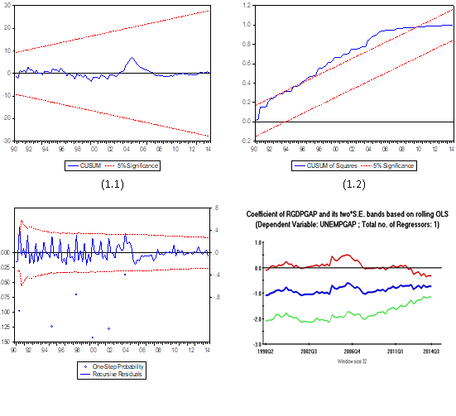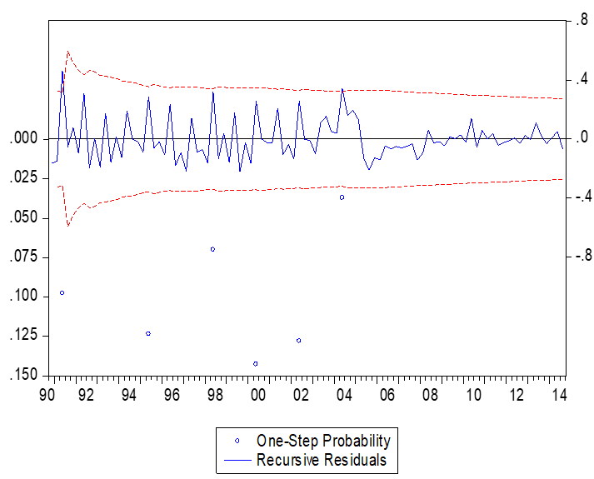

**Socio-economic factors**

Savings to income ratio

Financial status

Income adequacy

**Financial literacy**

**Financial behaviour**

**Debt burden**

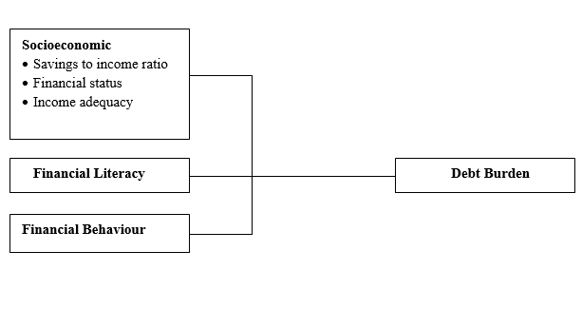

Fig. 2. (left) this framework is a non-editable diagram, appears blurry and hence, is unacceptable;   
(right) this framework is built using Ms Word illustration tools, has higher resolution and is acceptable.   
(Font = 9; Click ‘Caption B’ on the Styles Gallery)

Please use the ‘drawing canvas tool’ in MS Word before inserting any images or diagrams into the document. When constructing a conceptual/theoretical framework, please use editable or vector-based diagrams. Draw diagrams using MS Word’s Smart Art Graphic Tool (textboxes, labels, arrows, legends, etc.) rather than embedding non-editable image objects. Ensure that all the figures have a good resolution (minimum 300dpi) and are not fuzzy or blurry.

2.2 Captions

The figure number and caption should be typed below the illustration in 9pt and left justified. Artwork has no text along the side of it in the main body of the text. However, if two images fit next to each other, these may be placed next to each other to save space, see Fig 1. They must be numbered consecutively, all figures, and all tables respectively.

3.0 Equations and formulas

Equations and formulae should be typed and numbered consecutively with Arabic numerals in parentheses on the right-hand side of the page (if referred to explicitly in the text). They should also be separated from the surrounding text by one space. If you chose to use the Equation Editor, please ensure that the manuscript is saved using .docx format (rather than .doc), and Compatibility Mode is turned off.

|  |  |  |
| --- | --- | --- |
|  | Rt = K EP = 93.02 (±9.62) – 13.45 | (1) |

****4.0 CITING AND REFERENCING GUIDE****

****4.1 Citation in text****

Please ensure that every reference cited in the text is also present in the reference list (and vice versa). Please follow the APA Citing Guide (7th Edition). <https://apastyle.apa.org/style-grammar-guidelines/citations/basic-principles/parenthetical-versus-narrative>

All citations in the text should refer to:

1. Single author: the author's name and the year of publication.
2. Two authors: both authors' names and the year of publication.
3. Three or more authors: first author's name followed by 'et al.' and the year of publication.

Citations may be made narratively (directly) or parenthetically:

1. Parenthetical citation: Both author’s name and year which are separated by a comma, appear within or at the end of a sentence, eg (Julaihi et al., 2020).
2. Narrative citation: The author’s name appears in running text, and the year appears in parentheses immediately, eg. Julaihi et al. (2020) stated that…

****4.2 Reference Style****

The references should follow the APA Referencing Guide (7th edition). Please provide the DOIs or link for all references using active hyperlinks (blue and underlined). <https://apastyle.apa.org/style-grammar-guidelines/references/examples>

Examples:   
Reference to a journal publication:

Julaihi, N. H., Voon, L. L., & Tang, H. E. (2020). Teachers’ Efficacy Beliefs in Mathematics Teaching: A Study of Public Primary Schools in Sarawak. *International Journal of Service Management and Sustainability, 5*(1), 63– 82. <https://doi.org/10.24191/ijsms.v5i1.9860>

*Reference to a book:*

Bandura, A. (1997). *Self-efficacy: The exercise of control*. W.H. Freeman.

Reference to a conference proceeding:

Zakaria, M. H., Azziz, N. H. A., Yazid, N. M., & Saad, S. A. (2016). The anxiety level versus performance in mathematics for engineering undergraduates in UniMAP. *AIP Conference Proceedings, 1775(1). AIP Publishing*. <https://doi.org/10.1063/1.4965198>

Reference to a published dissertation:

Carter, N. (2022). *Measuring precalculus self-efficacy, grit, and achievement in university precalculus courses taught with an online flipped model* [Doctoral dissertation, University of Houston-Clear Lake]. ProQuest Dissertations and Theses Global. <https://uhcl-ir.tdl.org/handle/10657.1/2975>

Reference to a government agency report:

Malaysia Examinations Syndicate (2023). *Laporan Analisis Keputusan SPM 2022*. Ministry of Education Malaysia.[http://lp.moe.gov.my/files/spm/2023/Laporan%20Analisis%20Keputusan%20Peperiksaan_ %20SPM%202022.pdf](http://lp.moe.gov.my/files/spm/2023/Laporan%20Analisis%20Keputusan%20Peperiksaan_%20%20SPM%202022.pdf)

5.0 CONTRIBUTION OF AUTHORS

Each author’s contribution must be stated clearly reflecting each contribution to the body of the work and manuscript. Authors can refer to [CRediT](http://credit.niso.org/) (Contribution Roles Taxonomy) for detailed information about individual contributions to the work. For example:

Jaya Subramaniam carried out the research, wrote and revised the article. Rahmah Hassan conceptualized the central research idea and provided the theoretical framework. Rahmah Hassan and Chong Ju Lian designed the research and supervised research progress;

6.0 FUNDING

This section is compulsory. The following is an example of a funding statement:

This work received no specific grant from any funding agency.

7.0 Conflict of interest statement

This section is compulsory. The following is an example of a conflict-of-interest statement:

The authors agree that this research was conducted in the absence of any self-benefits, commercial or financial conflicts and declare the absence of conflicting interests with the funders.

8.0 Acknowledgement

This section is compulsory. The following is an example of an acknowledgement statement:

The authors would like to acknowledge the support of Universiti Teknologi MARA (UiTM) for providing facilities and financial support on this research. The authors also want to thank the reviewers and editors for the useful insights to improve this paper and the respondents who took part in the survey.

9.0 References

Bandura, A. (1997). Self-efficacy: The exercise of control. W.H. Freeman.

Carter, N. (2022). Measuring precalculus self-efficacy, grit, and achievement in university precalculus courses taught with an online flipped model [Doctoral dissertation, University of Houston-Clear Lake]. ProQuest Dissertations and Theses Global. <https://uhcl-ir.tdl.org/handle/10657.1/2975>

Julaihi, N. H., Voon, L. L., & Tang, H. E. (2020). Teachers’ efficacy beliefs in mathematics teaching: A study of public primary schools in Sarawak. International Journal of Service Management and Sustainability, 5(1), 63– 82. [https://doi.org/10.24191/ijsms.v5i1.9860](https://doi.org/10.24191/ijsms.v5i1.9860%20%20%20)

Malaysia Examinations Syndicate (2023). Laporan analisis keputusan SPM 2022. Ministry of Education Malaysia.[http://lp.moe.gov.my/files/spm/2023/Laporan%20Analisis%20Keputusan%20Peperiksaan%20SPM%202022.pd](http://lp.moe.gov.my/files/spm/2023/Laporan%20Analisis%20Keputusan%20Peperiksaan%20SPM%202022.pdg)f

|  |  |
| --- | --- |
|  | © 2025 by the authors. Submitted for possible open access publication under the terms and conditions of the Creative Commons Attribution (CC BY) license (http://creativecommons.org/licenses/by/4.0/). |

appendix

Authors including an appendix section should do so after References section. Multiple appendices should all have headings in the style used above. They will automatically be ordered A, B, C etc.

1. *Example of a heading within an appendix*
   1. *Example of a sub-heading within an appendix*

There is also the option to include a subheading within the Appendix if you wish.

**About the Authors**

***Author 1*** *(Full Name, without Titles/Designation)*, Please summarize the academic background and details of the author and contact information (an e-mail address is compulsory). The authors’ biographical information will be displayed after the Reference List. Maximum number of words is 100.

***Author 2*** *(Full Name, without Titles/Designation)*, Please summarize the academic background and details of the author and contact information (an e-mail address is compulsory). The authors’ biographical information will be displayed after the Reference List. Maximum number of words is 100.

*Example:****Nor Hazizah Julaihi***, is a senior lecturer at the Faculty of Computer and Mathematical Sciences, Universiti Teknologi MARA, Sarawak. Her main research activities are mathematical education and social sciences. She can be contacted via email at [norhazizah@uitm.edu.my](mailto:norhazizah@uitm.edu.my).

A MESSAGE FROM IJSMSust

The journal is managed by dedicated academic volunteers from UiTM, who balance their responsibilities in teaching, research, supervision, administration, and other academic duties. Therefore, authors are required to ensure that their submissions adhere to the following guidelines: (1) follow the specified format; (2) write the in-text citation and references according to APA 7th edition; (3) verify that all citations correspond with the reference list; and (4) ensure that tables and figures are in editable format. We highly appreciate your compliance with these guidelines when submitting your manuscript.

*Chief Editor*

*International Journal of Service Management and Sustainability (IJSMSust)*

*April 2025*

1. * Corresponding author. *E-mail address*: [donottypehere@email.com](mailto:donottypehere@email.com) (Please type)